**TITLE OF THE PROJECT**

**A Skill Oriented Course Web Application report** Submitted in the partial fulfilment of the requirements for the award of the degree of

Bachelor of Technology In

Computer Science and Engineering

by

# Saripalli Sri Chandana 22761A0547

Under the guidance of

**Dr. S. Nagarjuna Reddy,**

**Associate Professor, Dept. of CSE**



**Department of Computer Science and Engineering Lakireddy Bali Reddy College of Engineering (Autonomous) Accredited by NAAC & NBA (Under Tier - I)**

# Affiliated to JNTUK, Kakinada; ISO 9001:2015 Certified

**2023-24**

|  |  |
| --- | --- |
|  | **LAKIREDDY BALI REDDY COLLEGE OF ENGINEERING**  **(AUTONOMOUS)**  **Accredited by NAAC with ‘A’ Grade & NBA (Under Tier - I),**  **An ISO 21001:2018,14001:2015,50001:2018 Certified Institution Approved by AICTE, New Delhi and Affiliated to JNTUK, Kakinada**  **L.B. REDDY NAGAR, MYLAVARAM, NTR DIST., A.P.-521 230.**  [hodcse@lbrce.ac.in, cseoffice@lbrce.ac.in,](mailto:hodcse@lbrce.ac.in) Phone: 08659-222 933, Fax: 08659-222931  **DEPARTMENT OF COMPUTER SCIENCE & ENGINEERING** |

**CERTIFICATE**

This is to certify that the **“20CSS2-Web Application Development using Full Stack Module-I (Frontend Development)”** project entitled “**Event Management**” is being submitted by **Saripalli Sri Chandana (22761A0547)** in partial fulfilment for the award of B. Tech in Computer Science & Engineering to the Jawaharlal Nehru Technological University Kakinada is a record of bonafide work carried out by him/her under our guidance.

The results embodied in this Skill Oriented Course Web Application / Project report have not been submitted to any other University or Institute for the award of any degree or diploma.

## Project Guide Head of the department

Dr. S. Nagarjuna Reddy Dr. D. Veeraiah,

Associate Professor. Professor.

## External Examiner

**ACKNOWLEDGEMENT**

I would like to thank **Dr. S. Nagarjuna Reddy,** Associate Professor**,** CSE department for the encouraging and support in carrying out this Skill Oriented Course Web Application.

I also take the privilege to record my thanks to **Dr. D. Veeraiah,** Professor, Head of the Department of CSE whose encouragement, cooperation and valuable support crown my success.

I express my thanks to the support given by management in completing my Web Application / Project. I also express my sincere gratitude & deep sense of respect to the Principal, **Dr.K. Appa Rao** for making us available all the required assistance and his support and inspiration to carry out this Skill Oriented Course Web Application / Project in the Institute.

I am thankful to the teaching and non-teaching staff of CSE department for their direct as well as indirect help in my Skill Oriented Course Web Application / Project.

I am elated to avail my selves to this opportunity to express my deep sense of gratitude to my parents.

## ABSTRACT

The purpose of Event Management System is to automate the existing manual system by the help of computerized equipments and full-fledged computer software fulfilling there requirements, so that their valuable data/information can be stored for longer period with easy accessing and manipulation of the same. The required software and hardware are easily available and easy to work with.

Event Management System, described above, can lead to error free, secure, reliable and fast management system. It can assist the user to concentrate on their other activities rather to concentrate on the record keeping. Thus, it will help organization in better utilization of resources. The organization can maintain computerized records without redundant entries. That means that one need not be distracted by information that is not relevant, while being able to reach the information.

The aim is to automate its existing manual system by the help of computerized equipment and full-fledged computer software fulfilling their requirements, so that their valuable data/information can be stored for longer period with easy accessing and manipulation of the same. Basically the project describes how to manage for good performance and better services for the clients

**CONTENTS**

## CONCEPTS Page No

1. Introduction 6
2. Modules 7
3. Technologies Used
   1. HTML 8-12
   2. CSS 13-14
   3. JAVA SCRIPT 15
4. Implementation
   1. HTML Code 16-32
5. Screen Shots 33-36
6. Conclusion 37
7. Web References 37

# Introduction

# Event management, the most profound form of advertising and marketing, is a glamorous and thrilling profession. It provides an opportunity for unleashing one's creative potential to a very high degree. It demands a lot of hardwork and effort but at the same time offers enormous scope. Event management is a process of organizing a professional and focused event, for a particular target audience.

# It involves visualizing concepts, planning, budgeting, organizing and executing events such as Engagement, Sangeet, Haldi, Birthday, Marriage, etc. Event Management is a multi-million dollar industry, growing rapidly, with events planned regularly. Surprisingly, there is no formalized research conducted to access the growth of this industry.

# This project performs the task of developing a application that enables the customer retrieve the data very easily. The main purpose of event management system is to provide a platform for the users to view the information about the events that took place in the past and the ones which are about to take place in the near future.They can first login into the website and see through the information such as details about the events like the venue, theme of the event, participants, chief guests, etc. The administrator can login and update the information, delete any unwanted data, arrange the information accordingly so that the user can go through a user friendly

# Module

# Signup Module:

# Signup form collects user information (username,email,password,etc).

# Validations ensures correct data entry and format.User registration details processed and store data securely.Display confirmation after successful registration.

# Login Module:

# Intereface for users to enter credentials and verifies credentials (username and password). Display appropriate messages for incorrect credentials or other errors.

# Navigation Module:

The navigation bar provides clear and accessible links to key sections of the

Website, including Home page, About Us page, Services page, Gallery page,

contact Us page.

About Us Module:

The “About Us” section provides the information about missions, visions and

Experiences of Event management to the user.

Contact Us Module:

Contact Us page collects information like Email, mobile number, Name, Subject and Message. Contact page allows customers to interact with us broadly.

Gallery Module:

Collection of recent events are grouped in the gallery page. Customer can select his/Her favourite stage decoration and they can customize according to their flexibility.

# Technologies Used

## HTML :

HTML is an acronym which stands for **Hyper Text Markup Language** which is used for creating web pages and web applications. Let's see what is meant by Hypertext Markup Language, and Web page.

**Hyper Text:** Hyper Text simply means "Text within Text." A text has a link within it, is a hypertext. Whenever you click on a link which brings you to a new webpage, you have clicked on a hypertext. Hyper Text is a way to link two or more web pages (HTML documents) with each other.

**Markup language:** A markup language is a computer language that is used to apply layout and formatting conventions to a text document. Markup language makes text more interactive and dynamic. It can turn text into images, tables, links, etc.

**Web Page:** A web page is a document which is commonly written in HTML and translated by a web browser. A web page can be identified by entering an URL. A Web page can be of the static or dynamic type. **With the help of HTML only, we can create static web pages**.

Hence, HTML is a markup language which is used for creating attractive web pages with the help of styling, and which looks in a nice format on a web browser. An HTML document is made of many HTML tags and each HTML tag contains different content.

**<!DOCTYPE>:** It defines the document type or it instruct the browser about the version of HTML.

**<html>**: This tag informs the browser that it is an HTML document. Text between html tag describes the web document. It is a container for all other elements of HTML except <!DOCTYPE>

**<head>:** It should be the first element inside the <html> element, which contains the metadata (information about the document). It must be closed before the body tag opens.

**<title>:** As its name suggested, it is used to add title of that HTML page which appears at the top of the browser window. It must be placed inside the head tag and should close immediately. (Optional)

**<body>**: Text between body tag describes the body content of the page that is visible to the end user. This tag contains the main content of the HTML document.

In the late 1980's, a physicist, Tim Berners-Lee who was a contractor at CERN, proposed a system for CERN researchers. In 1989, he wrote a memo proposing an internetbased hypertext system.

**Tim Berners-Lee** is known as the father of HTML. The first available description of HTML was a document called "HTML Tags" proposed by Tim in late 1991. The latest version of HTML is HTML5, which we will learn later in this tutorial.

HTML Tags:-

Tag Description

|  |  |
| --- | --- |
| [<br>](https://www.javatpoint.com/html-br-tag) | It is used to apply single line break. |
| [<button>](https://www.javatpoint.com/html-button-tag) | It is used to represent a clickable button |
| [<dd>](https://www.javatpoint.com/html-description-list) | It is used to provide definition/description of a term in description list. |
| [<div>](https://www.javatpoint.com/html-div-tag) | It defines a division or section within HTML document. |
| [<dl>](https://www.javatpoint.com/html-description-list) | It is sued to define a description list. |
| [<dt>](https://www.javatpoint.com/html-description-list) | It is used to define a term in description list. |
| [<fieldset>](https://www.javatpoint.com/html-fieldset-tag) | It is used to group related elements/labels within a web form. |
| [<h1 to <h6>](https://www.javatpoint.com/html-heading) | It defines headings for an HTML document from level 1 to level 6. |
| [<hr>](https://www.javatpoint.com/html-hr-tag) | It is used to apply thematic break between paragraph-level elements. |
|  |  |
| [<img>](https://www.javatpoint.com/html-image) | It is used to insert an image within an HTML document. |
| [<input>](https://www.javatpoint.com/html-input-tag) | It defines an input field within an HTML form. |
| [<label>](https://www.javatpoint.com/html-label-tag) | It defines a text label for the input field of form. |
| [<legend>](https://www.javatpoint.com/html-legend-tag) | It defines a caption for content of <fieldset> |
| [<li>](https://www.javatpoint.com/html-lists) | It is used to represent items in list. |
| [<link>](https://www.javatpoint.com/html-link-tag) | It represents a relationship between current document and an external resource. |
| [<marquee>](https://www.javatpoint.com/marquee-html) | It is used to insert the scrolling text or an image either horizontally or vertically. |
| [<nav>](https://www.javatpoint.com/html-nav-tag) | It represents section of page to represent navigation links. |
| [<option>](https://www.javatpoint.com/html-option-tag) | It is used to define options or items in a drop-down list. |
| [<p>](https://www.javatpoint.com/html-paragraph) | It represents a paragraph in an HTML document. |
| [<pre>](https://www.javatpoint.com/html-pre-tag) | It defines preformatted text in an HTML document. |
| [<script>](https://www.javatpoint.com/html-script-tag) | It is used to declare the JavaScript within HTML document |
| [<select>](https://www.javatpoint.com/html-select-tag) | It represents a control which provides a menu of options. |
| [<strong>](https://www.javatpoint.com/html-strong-tag) | It is used to define important text. |
| [<style>](https://www.javatpoint.com/html-style) | It is used to contain style information for an HTML document. |
| [<sub>](https://www.javatpoint.com/html-sub-tag) | It defines a text which displays as a subscript text. |
| [<sup>](https://www.javatpoint.com/html-sup-tag) | It defines a text which represent as superscript text. |
| [<table>](https://www.javatpoint.com/html-table) | It is used to present data in tabular form or to create a table within HTML document. |
| [<textarea>](https://www.javatpoint.com/html-textarea) | It is used to define multiple line input, such as comment, feedback, and review, etc. |
| [<th>](https://www.javatpoint.com/html-th-tag) | It defines the head cell of an HTML table. |
| [<ul>](https://www.javatpoint.com/html-unordered-list) | It defines unordered list of items. |
| [<video>](https://www.javatpoint.com/html-video) | It is used to embed a video content with an HTML document |
| [<u>](https://www.javatpoint.com/html-u-tag) | It is used to render enclosed text with an underline. |
| [<head>](https://www.javatpoint.com/html-head) | It defines the head section of an HTML document. |
| [<html>](https://www.javatpoint.com/html-html-tag) | It represents root of an HTML document. |
| [<form>](https://www.javatpoint.com/html-form) | It is used to define an HTML form. |
| [<frame>](https://www.javatpoint.com/html-frame-tag) | It defines a particular area of webpage which can contain another HTML file. |
| [<dd>](https://www.javatpoint.com/html-description-list) | It is used to provide definition/description of a term in description list. |
| [<caption>](https://www.javatpoint.com/html-caption-tag) | It is used to define a caption for a table. |
| [<center>](https://www.javatpoint.com/html-center-tag) | It is used to align the content in center. |

## CSS:-

CSS stands for Cascading Style Sheet.CSS is used to design HTML tags.CSS is a widely used language on the web.HTML, CSS and JavaScript are used for web designing. It helps the web designers to apply style on HTML tags.CSS stands for Cascading Style Sheets. It is a style sheet language which is used to describe the look and formatting of a document written in markup language. It provides an additional feature to HTML. It is generally used with HTML to change the style of web pages and user interfaces. It can also be used with any kind of XML documents including plain XML, SVG and XUL

CSS is used along with HTML and JavaScript in most websites to create user interfaces for web applications and user interfaces for many mobile applications.You can add new looks to your old HTML documents.You can completely change the look of your website with only a few changes in CSS code.

* [Selector](https://developer.mozilla.org/en-US/docs/Learn/Getting_started_with_the_web/CSS_basics#selector)
* This is the HTML element name at the start of the ruleset. It defines the element(s) to be styled (in this example, [<p>](https://developer.mozilla.org/en-US/docs/Web/HTML/Element/p) elements). To style a different element, change the selector.
* [Declaration](https://developer.mozilla.org/en-US/docs/Learn/Getting_started_with_the_web/CSS_basics#declaration)
* This is a single rule like color: red;. It specifies which of the element's **properties** you want to style.
* [Properties](https://developer.mozilla.org/en-US/docs/Learn/Getting_started_with_the_web/CSS_basics#properties)
* These are ways in which you can style an HTML element. (In this example, color is a property of the [<p>](https://developer.mozilla.org/en-US/docs/Web/HTML/Element/p) elements.) In CSS, you choose which properties you want to affect in the rule.
* [Property value](https://developer.mozilla.org/en-US/docs/Learn/Getting_started_with_the_web/CSS_basics#property_value)

To the right of the property—after the colon—there is the **property value**. This chooses one out of The id selector uses the id attribute of an HTML element to select a specific element.The id of an element is unique within a page, so the id selector is used to select one unique element.To select an element with a specific id, write a hash (#) character, followed by the id of the element.many possible appearances for a given property

The style definitions are normally saved in external .css files.With an external stylesheet file, you can change the look of an entire website by changing just one file!

The class selector selects HTML elements with a specific class attribute.To select elements with a specific class, write a period (.) charThe universal selector (*) selects all HTML elements on the page.acter, followed by the class name.The grouping selector selects all the HTML elements with the same style definitions. With an external style sheet, you can change the look of an entire website by changing just one file!

Each HTML page must include a reference to the external style sheet file inside the <link> element, inside the head section.An internal style sheet may be used if one single HTML page has a unique style.The internal style is defined inside the <style> element, inside the head section.An inline style may be used to apply a unique style for a single element.

To use inline styles, add the style attribute to the relevant element. The style attribute can contain any CSS property.CSS comments are not displayed in the browser, but they can help document your source code.Comments are used to explain the code, and may help when you edit the source code at a later date.

Comments are ignored by browsers.A CSS comment is placed inside the <style> element, and starts with /* and ends with */: Margins are used to create space around elements, outside of any defined borders. The opacity property specifies theopacity/transparency of an element.

JAVASCRIPT:-

**JavaScript** is a lightweight, interpreted **programming** language. It is designed for creating network-centric applications. It is complimentary to and integrated with Java. **JavaScript** is very easy to implement because it is integrated with HTML.

It is open and cross-platform.Javascript is the most popular **programming language** in the world and that makes it a programmer’s great choice. Once you learnt Javascript, it helps you developing great front-end as well as back-end softwares using different Javascript based frameworks like jQuery, Node.

JS etc.Javascript is everywhere, it comes installed on every modern web browser and so to learn Javascript you really do not need any special environment setup.

For example Chrome, Mozilla Firefox , Safari and every browser you know as of today, supports Javascript.Javascript helps you create really beautiful and crazy fast websites.

You can develop your website with a console like look and feel and give your users the best Graphical User Experience.JavaScript usage has now extended to mobile app development, desktop app development, and game development.

This opens many opportunities for you as Javascript Programmer.Due to high demand, there is tons of job growth and high pay for those who know JavaScript. You can navigate over to different job sites to see what having JavaScript skills looks like in the job market.

Great thing about Javascript is that you will find tons of frameworks and Libraries already developed which can be used directly in your software development to reduce your time to market.

IMPLEMENTATION:-

HTML CODE:-

Elite_Events.html:-

<html>

<head>

<title>about</title>

<link rel="stylesheet" type="text/css" href="stylee.css">

<body>

<nav>

<center><nav><br>

<h1 color="white"style="font-size:28px;font-family:Lucida Calligraphy;color:white;"> Elite Event Management - " Life is an Event, Make it Memorable "</h1>

<a href="Elite_Events.html"><button class="button">Home</button></a>

<a href="about_us.html"><button class="button">About Us</button></a>

<div class="dropdown">

<button class="dropbtn">Services</button>

<div class="dropdown-content">

<a href="birthday_.html">Birthday</a>

<a href="engagement_.html">Engagement</a>

<a href="sangeet_.html">Sangeet</a>

<a href="haldi_.html">Haldi</a>

<a href="mehndi_.html">Mehndi</a>

<a href="marriage_.html">Marriage</a>

<a href="reception_.html">Reception</a>

</div>

</div>

<a href="gallery.html"><button class="button">Gallery</button></a>

<a href="contact_us.html"><button class="button">Contact Us</button></a>

<a href="login.html"><button class="button">Log in</button></a>

</nav><br>

<center><marquee class="marquee" loop=30 scrollamount=20 behavior="alternate"> “ Making your special moments even more special " </marquee>

</form>

</body>

</html>

Contact_us.html

<html>

<head>

<link rel="stylesheet" type="text/css" href="stylee.css"></head>

<body>

<nav>

<center><nav><br>

<a href="Elite_Events.html"><button class="button_">Home</button></a>

<a href="about_us.html"><button class="button_nav">About Us</button></a>

<div class="dropdown_nav">

<button class="dropbtn_nav">Services</button>

<div class="dropdown_nav-content">

<a href="birthday_.html">Birthday</a>

<a href="engagement_.html">Engagement</a>

<a href="sangeet_.html">Sangeet</a>

<a href="haldi_.html">Haldi</a>

<a href="mehndi_.html">Mehndi</a>

<a href="marriage_.html">Marriage</a>

<a href="reception_.html">Reception</a>

</div>

<a href="gallery.html"><button class="button_nav">Gallery</button></a>

<a href="contact_us.html"><button class="button_nav">Contact Us</button></a>

<a href="login.html"><button class="button_nav">Log in</button></a>

</nav>

</form><br

<center><form class="center" name="f1" action"send" unsubmit="return val()"><br>

<h1 class="h1" color="red">CONTACT US</h1><br>

<input type="text" name="t1" placeholder="Name" class="box" required><br><br>

<input type="email" name="t2" placeholder="Email" class="box" required><br><br>

<input type="number" name="t3" placeholder="phone/Mobile" class="box" required pattern=[0-9]{10}<br><br><br>

<input type="text" name="t4" placeholder="Subject" class="box" required><br><br>

<textarea placeholder="Message" name="t5" class="box"></textarea required><br><br>

<input type="submit" value="Send" class="button" style="background-color:green" required><br><br>

</form><br>

<form class="tab"><br><br>

<h3 class="h33">

<center>Elite Events – is a Event Managing company

in Andhra Pradesh,skilled in the areas of complete<br>

event management,entertainment, celebrity & artist

management,stage designing & fabrication, video and <br>

photography etc., It is a leading one of A.P’s premiere

Corporate Entertainment Event Companies since 2001.<br> </h3>

<h2>

<CENTER><form>

<h4 face="Bodoni MT" style="text-decoration:underline;color:white;">PAGES</h4>

<a href="Elite_Events.html"><input type="button" class="button3" value="HOME"></a><br>

<a href="about_us.html"><input type="button" class="button3" value="ABOUT US"></a><br>

<a href="gallery.html"><input type="button" class="button3" value="GALLERY"></a><br>

<a href="contact_us.html"><input type="button" class="button3" value="CONTACT"></a><br>

<h4 face="Bodoni MT" style="text-decoration:underline;color:white;" >CONTACT</h4>

<a href="contact_us.html"><input type="button" class="button3" value="9876543210"></a><br>

<a href="contact_us.html"><input type="button" class="button3" value="srushtiweddings@gmail.com"></a><br>

<a href="contact_us.html"><input type="button" class="button3" value=" # 33-26-10A,KASTURIBAIPET,Vijayawada, Andhra Pradesh 520010"></a><br>

<img src="f.jpg" class="imgg"><img src="i.jpg" class="imgg"><img src="w.jpg" class="imgg"><img src="in.jpg" class="imgg"><img src="t.jpg" class="imgg">

</form>

</body>

</html>

Sign.html:-

<html>

<head>

<link rel="stylesheet" type="text/css" href="stylee.css">

</head>

<body >

<nav>

<center><nav><br>

<a href="Elite_Events.html"><button class="button_">Home</button></a>

<a href="about_us.html"><button class="button_nav">About Us</button></a>

<div class="dropdown_nav">

<button class="dropbtn_nav">Services</button>

<div class="dropdown_nav-content">

<a href="birthday_.html">Birthday</a>

<a href="engagement_.html">Engagement</a>

<a href="sangeet_.html">Sangeet</a>

<a href="haldi_.html">Haldi</a>

<a href="mehndi_.html">Mehndi</a>

<a href="marriage_.html">Marriage</a>

<a href="reception_.html">Reception</a>

</div>

<a href="gallery.html"><button class="button_nav">Gallery</button></a>

<a href="contact_us.html"><button class="button_nav">Contact Us</button></a>

<a href="login.html"><button class="button_nav">Log in</button></a>

</nav>

</form><br>

<center><form class="center" name="myform" action="Success.html"><br>

<h1 class="h1" color="#fc0fc0">sign up</h1><br>

<input type="email" placeholder="Email" class="box" id="myEmail" pattern="[a-z0-9._%+-]+@[a-z0-9.-]+\.[a-z]{2,3}$" required><br><br>

<input type="text" placeholder="Fullname" class="box" pattern="[a-zA-Z]{3,}" required><br><br><br>

<input type="text" placeholder="Username" class="box" pattern="[a-zA-Z]{3,}" required><br><br><br>

<input type="password" placeholder="Password" id="psw" name="psw" pattern="(?=.*\d)(?=.*[a-z])(?=.*[A-Z]).{6,}" class="box" required><br><br><br><br>

<br><br>

<a href="Success.html"><button class="button">Submit</button></a>

</form><br><form class="tab"><br><br>

<h3 class="h33">

<center>Elite Events – is a Event Managing company

in Andhra Pradesh,skilled in the areas of complete<br>

event management,entertainment, celebrity & artist

management,stage designing & fabrication, video and <br>

photography etc., It is a leading one of A.P’s premiere

Corporate Entertainment Event Companies since 2001.<br> </h3>

<h2>

<CENTER>

</body>

</html>

Login.html:-

<html>

<head>

<link rel="stylesheet" type="text/css" href="stylee.css">

</head>

<body ><nav>

<center><nav><br>

<a href="Elite_Events.html"><button class="button_">Home</button></a>

<a href="about_us.html"><button class="button_nav">About Us</button></a>

<div class="dropdown_nav">

<button class="dropbtn_nav">Services</button>

<div class="dropdown_nav-content">

<a href="birthday_.html">Birthday</a>

<a href="engagement_.html">Engagement</a>

<a href="sangeet_.html">Sangeet</a>

<a href="haldi_.html">Haldi</a>

<a href="mehndi_.html">Mehndi</a>

<a href="marriage_.html">Marriage</a>

<a href="reception_.html">Reception</a>

</div>

<a href="gallery.html"><button class="button_nav">Gallery</button></a>

<a href="contact_us.html"><button class="button_nav">Contact Us</button></a>

<a href="login.html"><button class="button_nav">Log in</button></a>

</nav>

</form><br>

<center><form class="center" method="post" name="myform" action="Elite_Events.html"><br><br>

<h1 class="h1" color="red">Login</h1><br>

<input type="text" placeholder="Username" class="box" pattern="[a-zA-Z]{3,}" required><br><br>

<input type="password" placeholder="Password" class="box" pattern="(?=.*\d)(?=.*[a-z])(?=.*[A-Z]).{6,}" required><br><br>

<button type="submit" class="button">Submit</button><br><br>

Not registered?<a href="sign.html"><input type="button" class="button1" value="Sign up" /></a>

</form><br>

<form class="tab"><br><br>

</body>

</html>

Sangeet_.html:-

<html>

<head>

<title>Sangeet page</title>

<link rel="stylesheet" type="text/css" href="stylee.css">

</head>

<body bgcolor="#F0F0F0">

<nav>

<center><nav><br>

<a href="Elite_Events.html"><button class="button">Home</button></a>

<a href="about_us.html"><button class="button_nav">About Us</button></a>

<div class="dropdown_nav">

<button class="dropbtn_nav">Services</button>

<div class="dropdown_nav-content">

<a href="birthday_.html">Birthday</a>

<a href="engagement_.html">Engagement</a>

<a href="sangeet_.html">Sangeet</a>

<a href="haldi_.html">Haldi</a>

<a href="mehndi_.html">Mehndi</a>

<a href="marriage_.html">Marriage</a>

<a href="reception_.html">Reception</a>

</div>

<a href="gallery.html"><button class="button_nav">Gallery</button></a>

<a href="contact_us.html"><button class="button_nav">Contact Us</button></a>

<a href="login.html"><button class="button_nav">Log in</button></a>

</nav>

</form><br>

<div class="center">

<h1>sangeet</h1>

<h2>

Among the many pre-wedding events that occur prior to the Hindu, Punjabi, and Gujurati <br>wedding ceremonies,the Sangeet is where the party begins. <br>The word Sangeet translates to ‘sung together’ from Sanskrit. ‘Gaun’, another word <br>used to describe the event, means ‘songs’ or ‘to sing’ in Hindi. <br>Traditionally celebrated in the Punjab regions of India, this<br> ceremony has been adopted by many other regions as a form of celebration <br>for the wedding to come. The event is formally known to comprise<br> of only female attendees from both sides of the family, however modern<br> times allow for men to join in on the fun too. Unlike religious ceremonies such <br>as the Haldi or portions of the wedding ceremony, the Sangeet is solely conducted <br> to relish in the happiness and joy surrounding the couple.

</h2><br>

<h3> "Make your sangeet more colorful with our Elite Events.We love to work with you..!"</h3></div>

<br><h1>Recent Events</h1>

<div class="gallery">

<a href="s_.jpg"><img src="s_.jpg"></a>

<a href="s16.jpg"><img src="s16.jpg"></a>

</div>

<div class="popup">

<span>&times;</span>

<img src="m1.jpg"><br><br>

</div><br>

<CENTER><a href="sangeet.html"><button class="button">SANGEET GALLERY</button></a><br><

<form class="tab"><br><br>

<h3 class="h33" style="font-size:18px">

<center>Elite Events – is a Event Managing company

in Andhra Pradesh,skilled in the areas of complete<br>

event management,entertainment, celebrity & artist

management,stage designing & fabrication, video and <br>

photography etc., It is a leading one of A.P’s premiere

Corporate Entertainment Event Companies since 2001.<br> </h3>

</div>

</body><br><br>

</html>

Style.css:-

{

margin:0;

padding:0;

box-sizing:border-box;

}

h1

{

text-align: center;

color:#d916c1;

margin: 20px 0;

font-size: 50px;

font-family:Lucida Calligraphy;

}

.container

{

position:relative;

}

.gallery

{

display:flex;

flex-wrap:wrap;

justify-content:center;

width:100%;

}

.gallery img

{

width: 400px;

height: 300px;

padding: 20px;

object-fit:cover;

transition: all 4;

}

.gallery img:hover

{

cursor:pointer;

transform:scale(1.03);

box-shadow: opx opx 10px green;

}

.popup

{

position:fixed;

top:0;

left:0;

z-index:10;

width:100%;

height:100%;

display:none;

background-color:#aabbcc;

z-index:20;

}

.popup span

{

position:absolute;

top:0;

right:10px;

color:white;

cursor:pointer;

font-size:40px;

cursor:pointer;

z-index:20;

}

.popup img

{

position:absolute;

top:50%;

left:50%;

transform:translate(-50%,-50%);

max-width:750px;

object-fix:cover;

}

@media(max-width:768px)

{

.popup img

{

width:95%;

}

}

gallery img a

{

max-width: 100%;

height: auto;

}

SCREENSHOTS:-

HOME PAGE:-

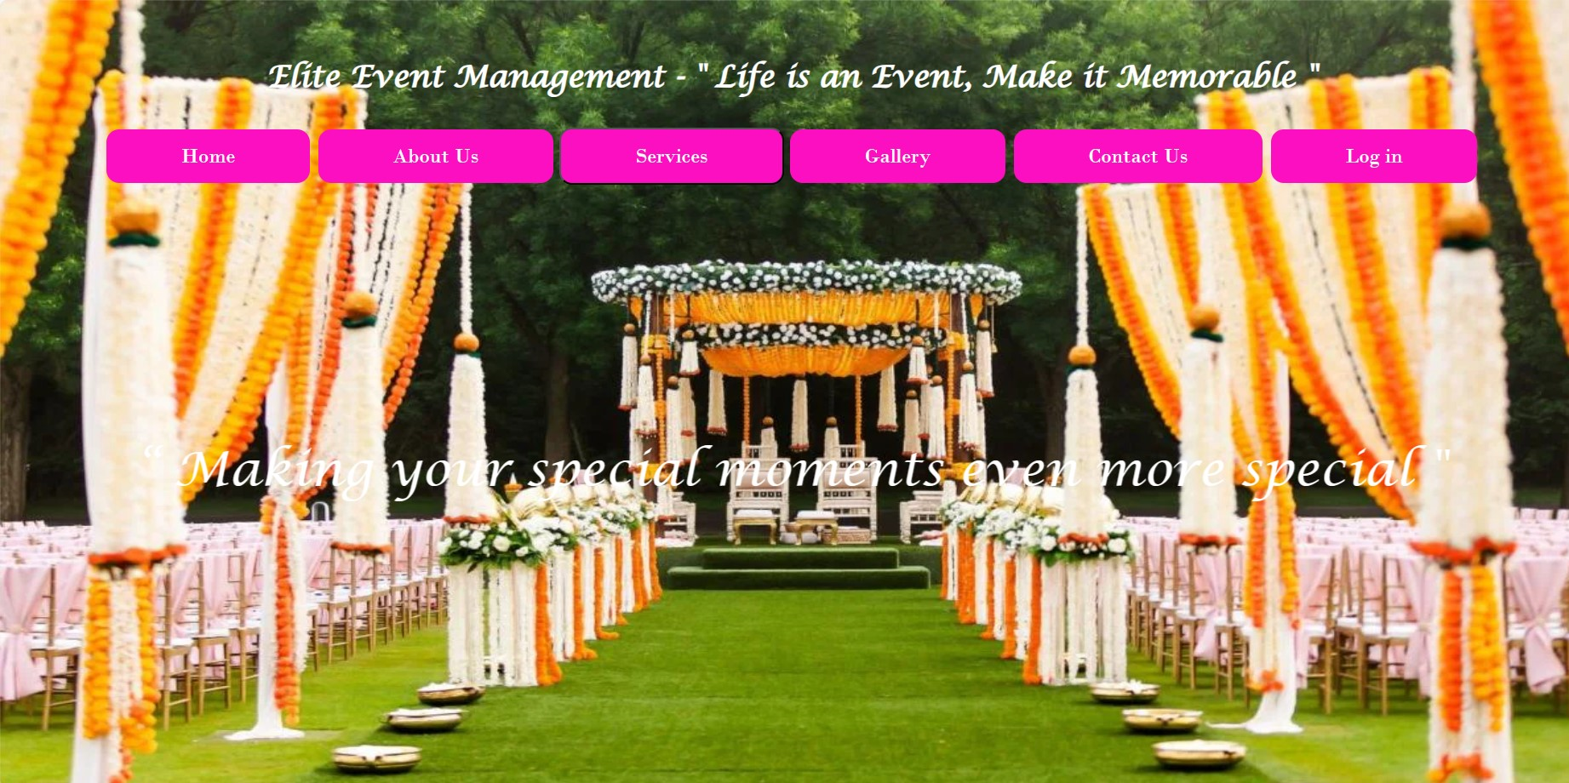

ABOUT US PAGE:-

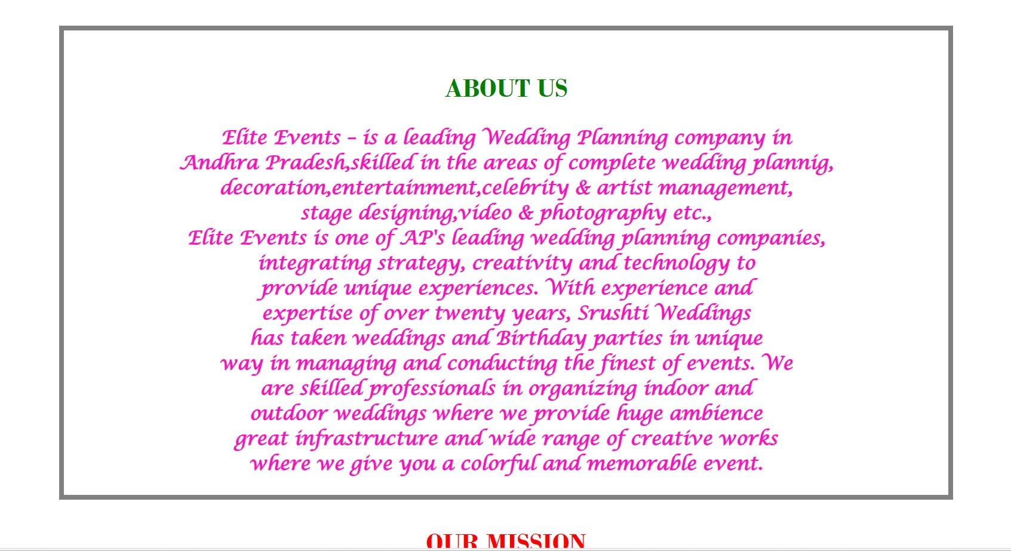

EVENT PAGE:-

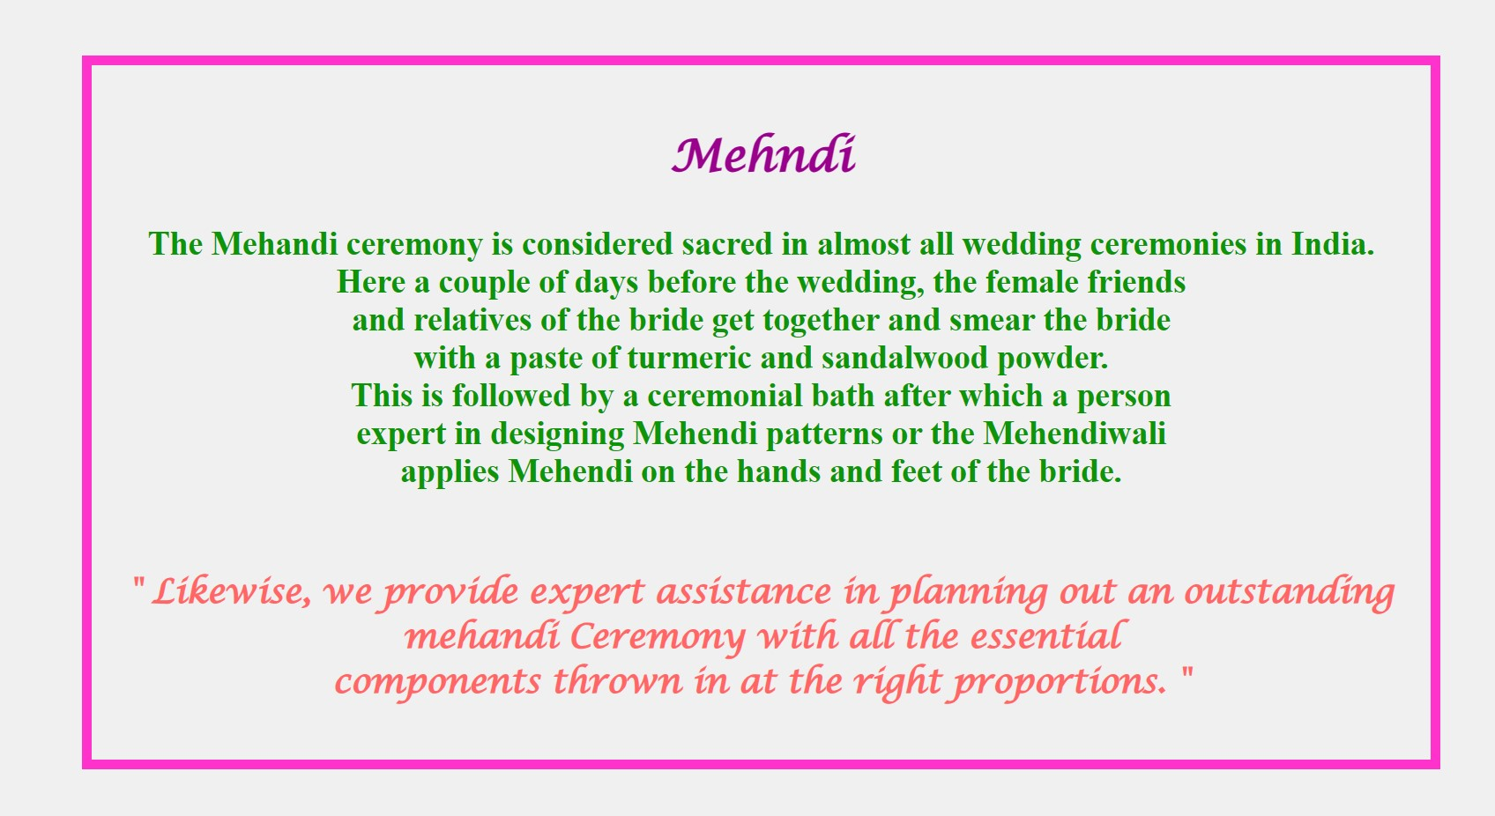

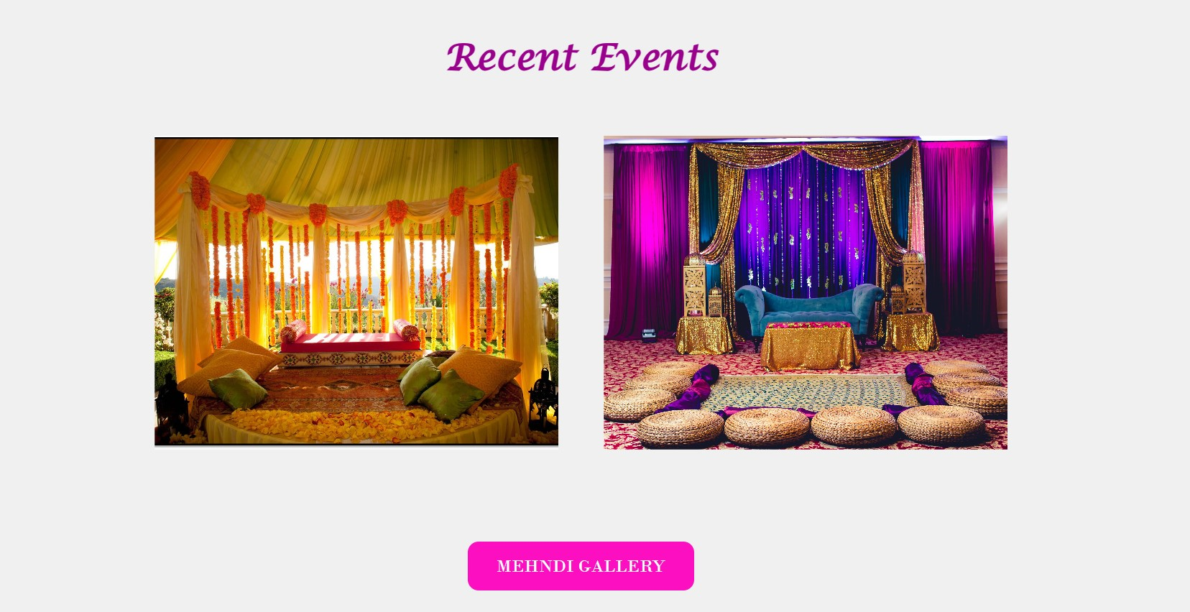

**GALLERY:-**

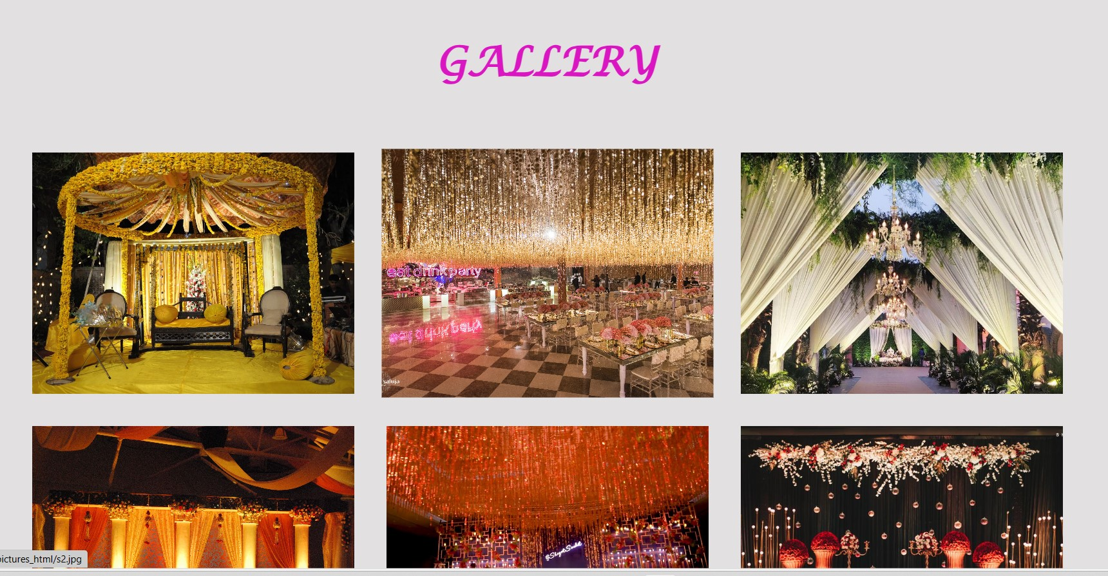

CONTACT US

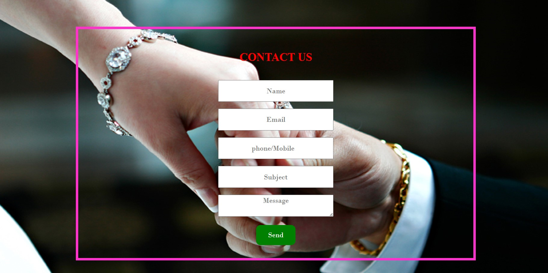

LOGIN PAGE

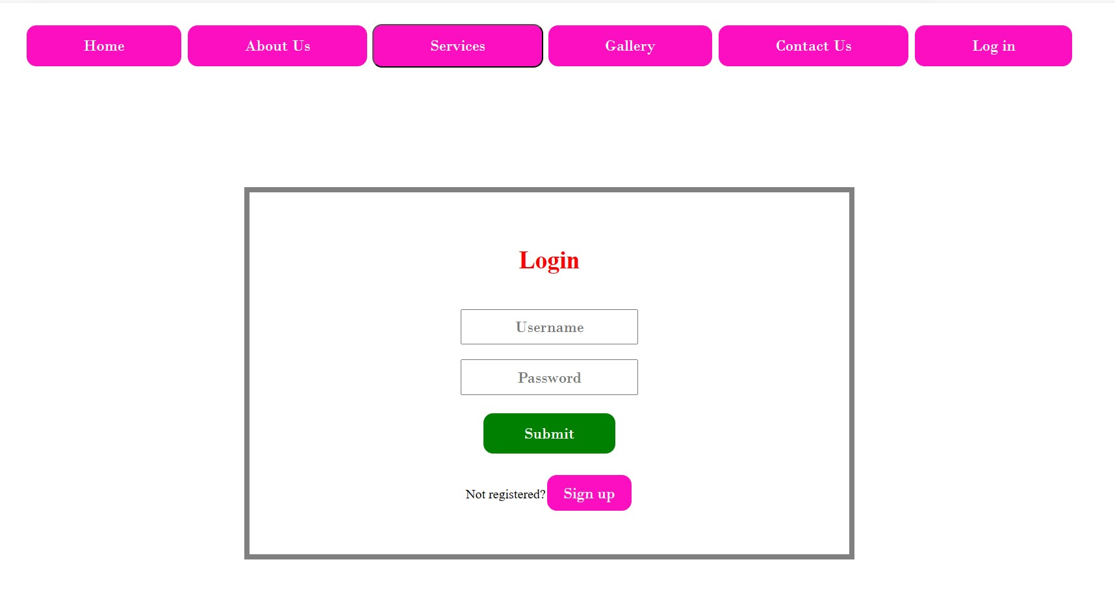SIGN UP PAGE:-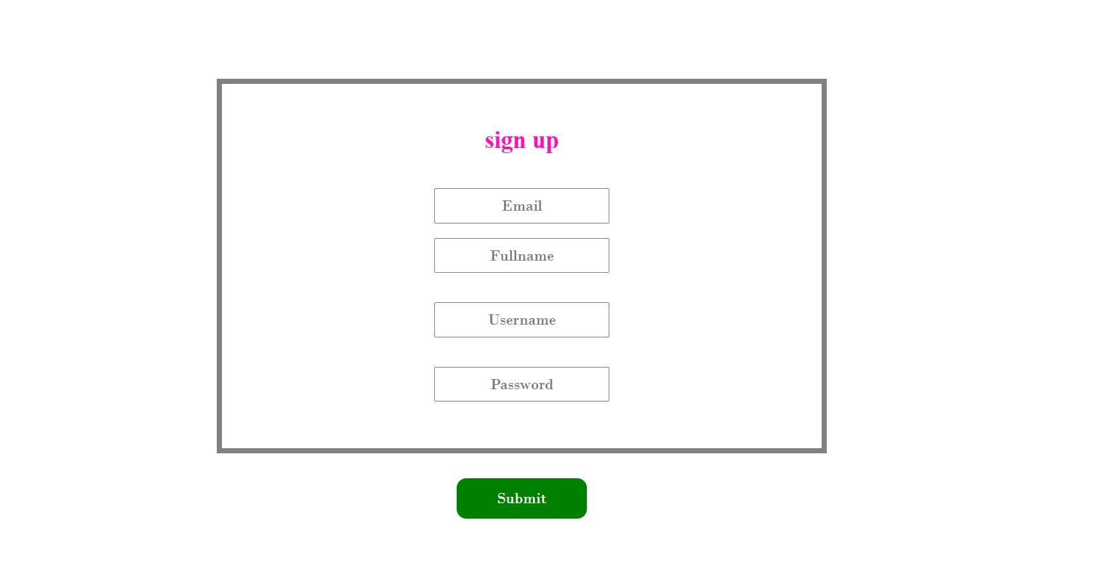

CONCLUSION:-

Event management is a glamorous and exciting profession which demands a lot of hard work and dynamism. As the name suggests, it means conceptualizing, planning, organizing and finally executing an event. The event could be of any type - musical show, concert, exhibition, product launching etc. This industry is just eight years old in India, but holds a lot of promise for expansion. It offers enormous scope for ambitious young people. Event management is the planning and implementation of events, large and small that meet the marketing goals of an organization.

Event management is an area that is growing rapidly, and is expected to have a better growth rate in the next decade.

 Typical events organized by

professional event managers include product launches, parties, sponsored events, sportingevents, competitions, concerts and festivals, fundraisers, trade shows, corporate open days, seminars and

tours.

REFERENCES

<https://www.w3schools.com>

<https://www.geeksforgeeks.org>

<https://www.tutorialspoint.com/>

[www.srushtievents.com](http://www.srushtievents.com)

